Cl-3001 - Coputer networks lab

LABORATORY MANUAL ⦁Spring 2023 ⦁Student ID – K-21-0026: Muhammad Nadeem

|  |
| --- |
| **LAB 11** |
| **Implementation & understanding of**  **VLANS** |



|  |  |  |  |  |
| --- | --- | --- | --- | --- |
|  | | | | |
|  | | | | |
|  | | | | |
| **Muhammad Nadeem** | | **K20-1052** | |  |
| ________________________________________ | | __________ | |  |
| STUDENT NAME | | ROLL NO | |  |
|  | | | | |
| ______________________________________ | | | | |
| SIGNATURE & DATE | | | | |
| **MARKS AWARDED: ______________** | | | | |
| ___________________________________________________________________ | | | | |
| **NATIONAL UNIVERSITY OF COMPUTER AND EMERGING SCIENCES (NUCES), KARACHI** | | | | |
| Version: 1.0  Date: 17th **February 2023** | | | | |
| Instructor Name:  Prepared by: | **Muhammad Nadeem Ghouri**  **S.M.HASSAN ALI** |  |  | |

**Lab Session 11**

**Q1**

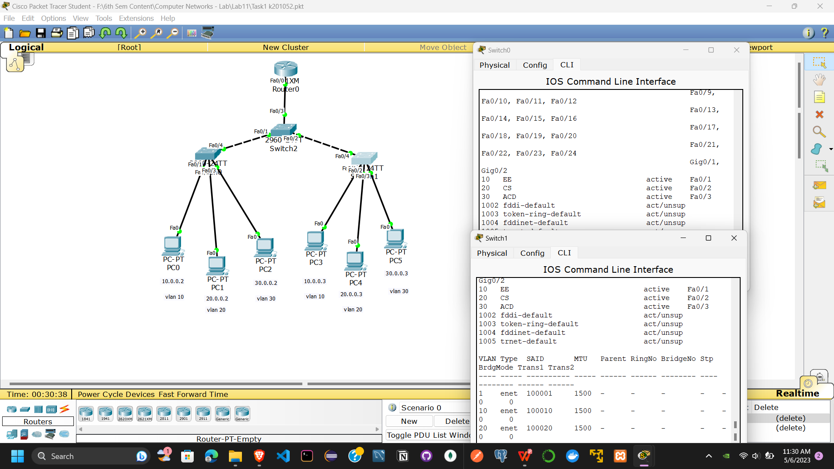

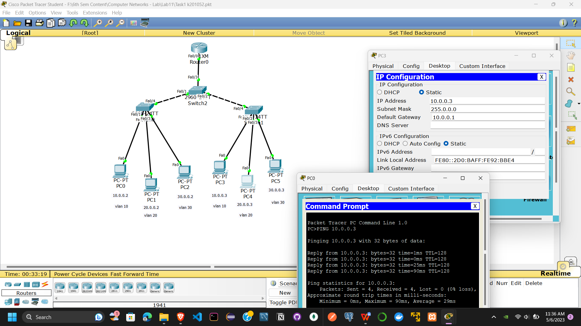

Q2

